Supporting Information
DeepRMSF: a deep learning-based automated approach for predicting atomic-level flexibility in RNA structure

Chenjie Feng^{1†}, Xiaowen Sun^{3†}, Xintao Song³, Lei Bao⁴, Weikang Gong^{2*} and Renmin Han^{3,5*}

¹ College of Medical Information and Engineering, Ningxia Medical University, Yinchuan 750004, China.
² Center for AI and Computational Biology, Suzhou Institute of Systems Medicine, Chinese Academy of Medical Sciences & Peking Union Medical College, Suzhou 215123, China.
³ Research Center for Mathematics and Interdisciplinary Sciences, Shandong University, Qingdao 266237, China.
⁴ School of Public Health, Hubei University of Medicine, Shiyan, Hubei 442000, China.
⁵ Syneron Opal, George Town 10281, the Cayman Islands

†Joint-first authors.

*Co-corresponding authors: gwk@ism.cams.cn and hanrenmin@sdu.edu.cn.

Section S1. Dataset Construction for Cross-Validation and External Test Set
To construct a fair and rigorous evaluation framework, we curated 371 RNA structures from the Protein Data Bank (PDB). The dataset construction followed a two-step strategy:
First, 60 RNA structures were selected as an independent external test set. To ensure high quality and minimal redundancy, each RNA in the external set was required to have a sequence identity below 60% and a TM-score below 0.45 compared to any RNA in the cross-validation folds. The TM-score threshold was selected based on prior literature, where a TM-score above 0.45 indicates significant structural similarity between RNA molecules[1]. This constraint ensures that the external set represents structurally and sequentially distinct targets, enabling robust testing of model generalization.
Second, the remaining 311 RNA structures were partitioned into five folds for cross-validation. To ensure both sequence and structural redundancy control within the five-fold cross-validation framework while maintaining balanced distribution across folds. We constructed similarity clusters by grouping any RNA pair with sequence identity >80% and TM-score >0.45 was placed in the same fold. This fold assignment strategy effectively prevents splitting of homologous or highly similar RNA structures across training and validation subsets, while maintaining a reasonably balanced distribution across the five folds.

Section S2. All-atom molecular dynamics simulations
In order to control constant pressure, we used the isotropic Berendsen barostat with a time constant of 2 ps. During the equilibration and production process, the RNA structure was completely free in the solutions. Simulations were run with an integration step of 2 fs, and bond lengths for hydrogen atoms were ﬁxed using the SHAKE algorithm[2]. PME electrostatics was calculated with an Ewald radius of 10 Å and the cutoff distance was also set to 10 Å for the van der Waals potential. Trajectories were processed and analyzed by the built-in Cpptraj module of Amber Tools package. In order to ensure a rigorous comparison between different trajectories, we first removed the translational and rotational motion of all RNA molecule. Then, the average structure of each RNA (only heavy atoms) were calculated as a reference structure. After that, each conformation in the trajectory was aligned to the reference structure and RMSF of the RNA molecule was output.

Section S3. RMSF Normalization Strategy
To enable direct comparison between predicted and MD-derived RMSF values in the same physical scale, we applied a linear scaling transformation to the predicted RMSF values in Figure 5 and related analyses. Specifically, the predicted RMSF values were mapped to the numerical range of MD-RMSF using min-max scaling:

$${predict RMSF}_{scaled}=\frac{Predict RMSF-\min\left(Predict RMSF\right)}{\max\left(Predict RMSF\right)-\min\left(Predict RMSF\right)}×\left(\max\left(MD-derved RMSF\right)-\min\left(MD-derived RMSF\right)\right)+min⁡(MD-derived RMSF)$$

This procedure preserves the relative fluctuation patterns of the prediction while ensuring non-negativity and physical interpretability.
We emphasize that this transformation was applied only for visualization and comparative purposes, and that the original outputs of the prediction model are all non-negative.
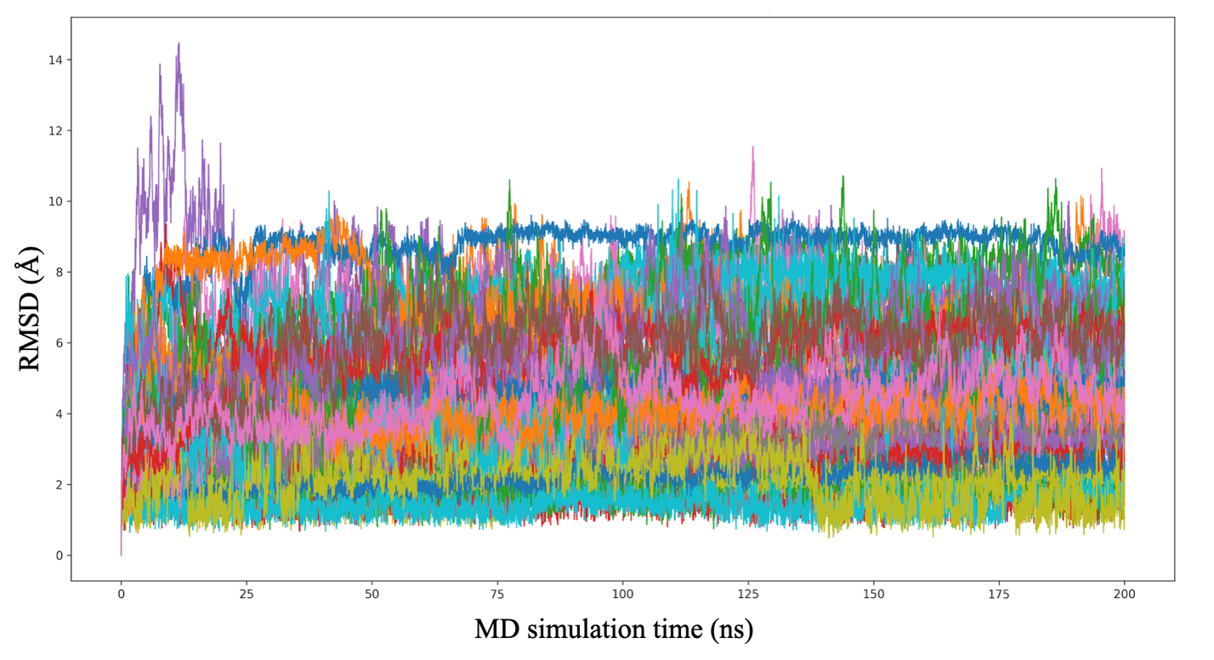
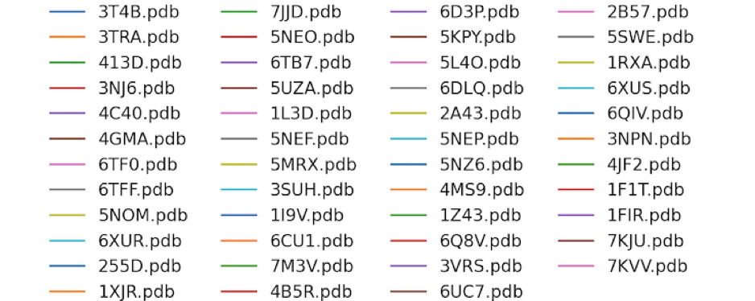
Figure S1. RMSD profiles to assess MD simulation equilibration.
To evaluate the equilibration behavior during MD simulations, we randomly selected 50 RNA molecules from the full dataset of 371 RNAs. For each RNA, the root mean square deviation (RMSD) relative to simulation time over the 200 ns production run.

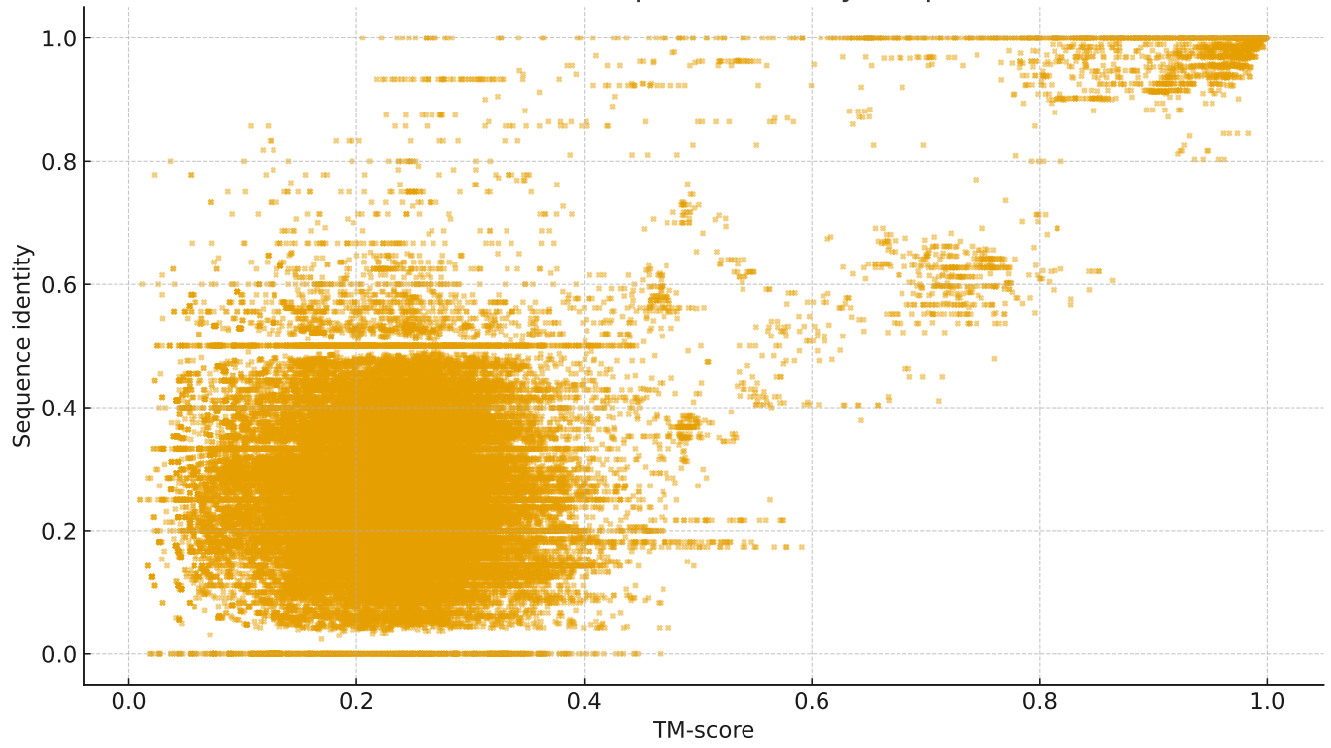

Figure S2. Distribution of model performance across repeated cross-validation runs.

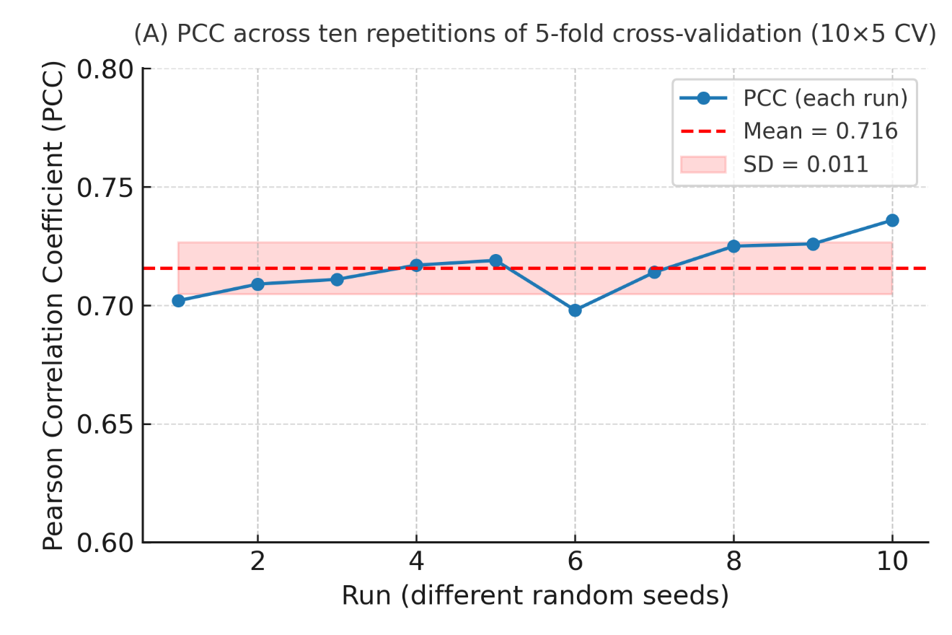

Figure S3. Distribution of model performance across repeated cross-validation runs.
Distribution of Pearson correlation coefficients obtained from ten independent randoms, earch using five-fold cross-validation.
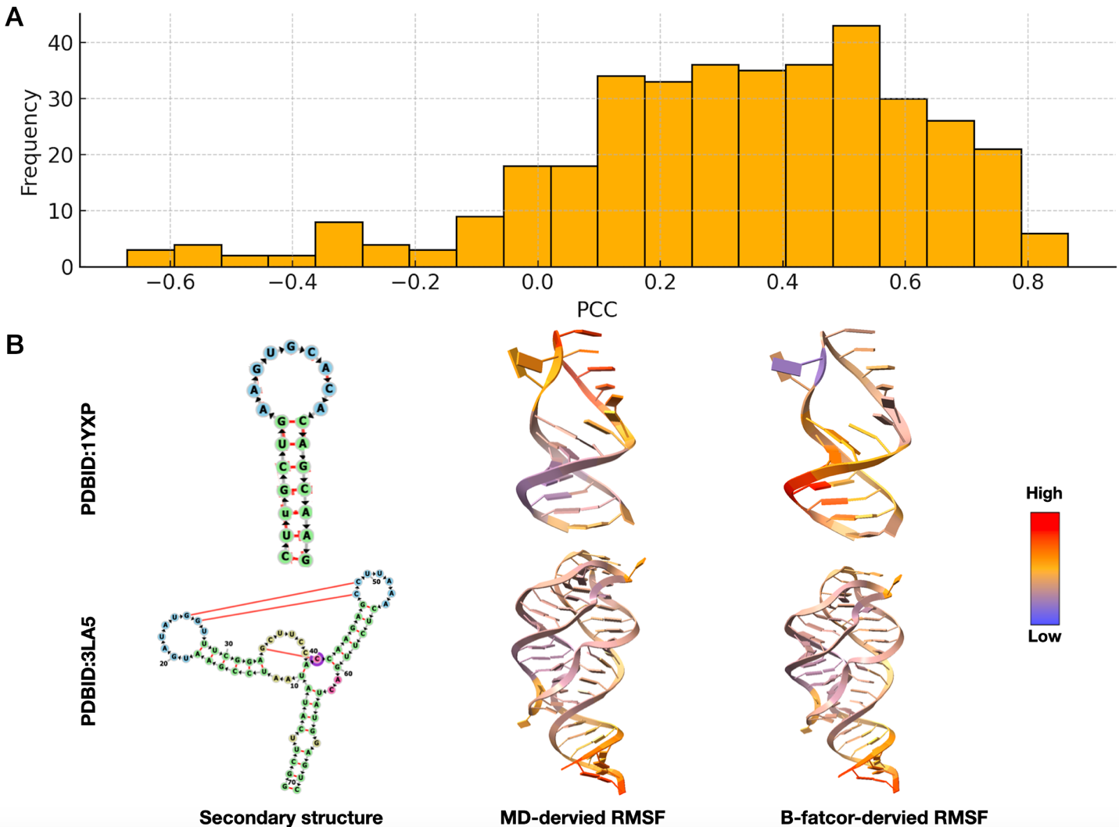

Figure S4. Comparison between MD-derived RMSF and B-factor-derived RMSF across RNA structures. A. The distribution of PCC between MD-derived RMSF and B-factor-derived RMSF values.
B. The secondary structures and corresponding RMSF distributions are displayed for two RNAs. The hairpin RNA (PDB ID: 1YXP) and the multi-helix junction RNA (PDB ID: 3LA5).
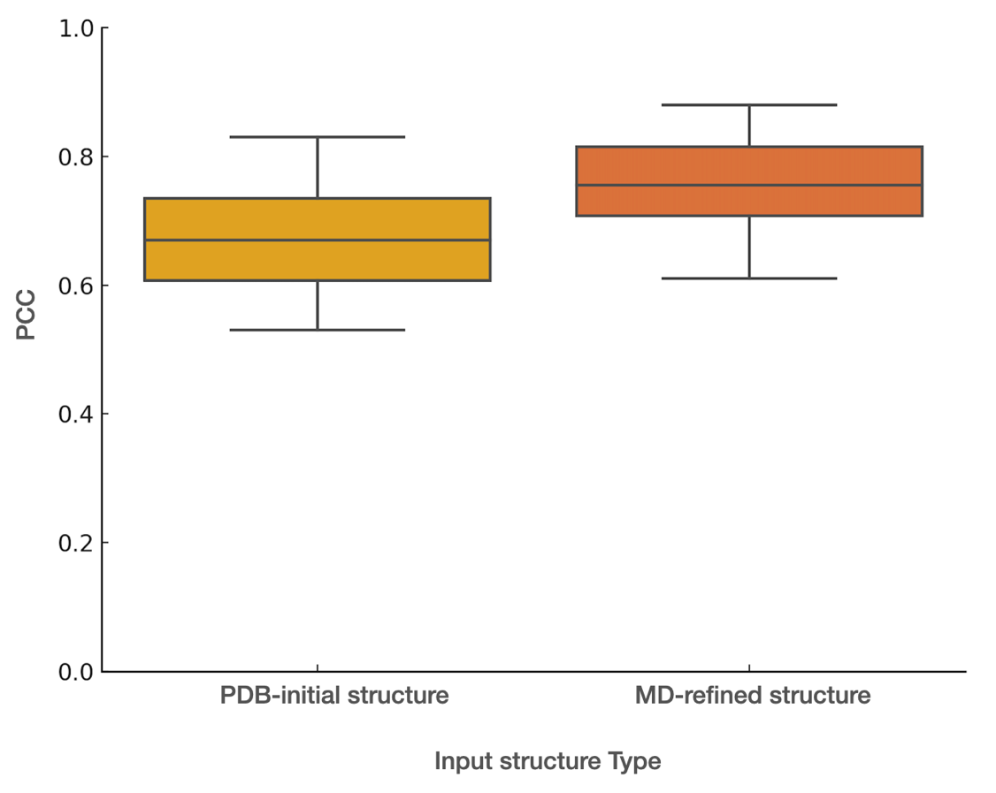
Figure S5. Impact of input structure quality on DeepRMSF prediction performance.
The RMSF prediction distribution of PCC between PDB-initial structures and MD-equilibrated structures as input structures.

Figure S6. Distribution of ligands in the flexibility map structure predicted by DeepRMSF.

We calculated the PCC obtained by GNM and pfGNM and compared with DeepRMSF. In traditional ENM, a RNA structure is represented as an elastic network of some atoms (here P) where the node pairs within a cutoff distance (r_{c}) are connected by springs with a uniform force constant. In GNM, the total internal potential energy of the network of N nodes can be written as
where γ is the spring force constant, the column vector △R represents the fluctuation of the N nodes, △R^{T} is the transpose matrix of △R, E is the unitary matrix, is the matrix direct product, and Γ is the N×N symmetric Kirchhoff matrix, the elements of which are described as
where r_{c} is the cutoff distance (here, r_{c}=16Å) and R_{ij} is the distance between the ith and jth nodes. Different from the traditional cutoff-based ENM, the parameter-free ENM (pfENM) adopts a distance-dependent spring constant set. In pfENM, some atoms (here also P) are selected as nodes. All the node pairs are considered to be interacting with each other with the strength being inversely proportional to their square distance. In pfGNM, the elements of the Kirchhoff matrix Γ^{pfGNM} are calculated as
where R_{ij} is the distance between the ith and jth nodes. In GNMs, the mean-square fluctuation of each nucleotide is in proportion to the diagonal elements of the pseudoinverse of Kirchhoff matrix.
where k_{B} is the Boltzmann constant, and T is the thermodynamic temperature. The pseudoinverse of Kirchhoff matrix can be decomposed as
where λ_{k} and μ_{k} are the kth eigenvalue and eigenvector of Kirchhoff matrix, respectively. Since three of the 371 systems do not contain P atoms, we evaluated the PCC values of GNM and pfGNM based on the remaining 368 systems (see Table 1). According to the average PCC values, DeepRMSF (0.719±0.02) significantly outperforms GNM (0.441±0.3) and pfGNM (0.490±0.326).

Table S1. 368 RNAs in the dataset constructed by us and their PCC values obtained by the two GNM methods
PDB  ID | PCC values
PDB  ID | GNM | pfGNM | DeepRMSF
1d4r | 0.731 | 0.832 | 0.725
1duh | 0.526 | 0.646 | 0.698
1ehz | 0.571 | 0.341 | 0.712
1evv | 0.609 | 0.533 | 0.705
1f1t | 0.354 | 0.326 | 0.695
1fir | 0.289 | 0.101 | 0.688
1hr2 | 0.626 | 0.634 | 0.718
1i9v | 0.824 | 0.847 | 0.734
1i9x | 0.000 | 0.174 | 0.682
1k9w | -0.304 | -0.061 | 0.675
1kd4 | 0.915 | 0.974 | 0.742
1kfo | 0.964 | 0.872 | 0.748
1kh6 | 0.306 | 0.310 | 0.701
1kxk | 0.650 | 0.672 | 0.721
1l3d | -0.140 | -0.527 | 0.668
1l8v | 0.750 | 0.769 | 0.728
1mhk | 0.712 | 0.768 | 0.726
1nbs | 0.702 | 0.705 | 0.724
1nlc | 0.259 | 0.261 | 0.697
1o3z | 0.232 | 0.379 | 0.699
1q93 | 0.657 | 0.737 | 0.722
1q96 | -0.115 | -0.329 | 0.673
1t0e | -0.254 | -0.430 | 0.665
1tn1 | 0.714 | 0.648 | 0.723
1u9s | 0.679 | 0.724 | 0.725
1vtq | 0.857 | 0.846 | 0.738
1wvd | 0.323 | 0.419 | 0.703
1x8w | 0.741 | 0.722 | 0.729
1xjr | 0.421 | 0.481 | 0.708
1xp7 | -0.352 | -0.209 | 0.662
1xpe | -0.110 | 0.017 | 0.678
1xpf | -0.184 | -0.084 | 0.672
1y0q | 0.682 | 0.691 | 0.724
1y26 | 0.594 | 0.687 | 0.719
1y27 | 0.523 | 0.559 | 0.715
1y3o | -0.070 | -0.007 | 0.684
1y3s | 0.013 | 0.070 | 0.686
1y6s | 0.580 | 0.604 | 0.717
1y6t | 0.606 | 0.706 | 0.720
1y73 | 0.557 | 0.653 | 0.718
1y90 | 0.488 | 0.586 | 0.714
1y95 | 0.704 | 0.697 | 0.725
1y99 | -0.213 | -0.406 | 0.664
1yxp | -0.191 | -0.155 | 0.667
1yzd | -0.572 | 0.827 | 0.658
1z43 | 0.430 | 0.567 | 0.711
1zci | -0.372 | -0.178 | 0.659
1zev | 0.630 | 0.766 | 0.723
1zfx | 0.653 | 0.678 | 0.722
283d | 0.855 | 0.827 | 0.741
2b57 | 0.617 | 0.593 | 0.719
2b8r | -0.222 | -0.062 | 0.674
2b8s | -0.304 | -0.102 | 0.669
2bcz | 0.368 | 0.272 | 0.702
2ees | 0.633 | 0.695 | 0.721
2eet | 0.687 | 0.718 | 0.725
2eeu | 0.432 | 0.440 | 0.708
2eev | 0.674 | 0.686 | 0.724
2eew | 0.620 | 0.678 | 0.722
2f4s | 0.820 | 0.802 | 0.735
2f4t | 0.585 | 0.752 | 0.720
2f4u | 0.708 | 0.647 | 0.723
2fcx | -0.093 | -0.044 | 0.681
2fcy | -0.332 | -0.167 | 0.661
2fcz | -0.226 | -0.173 | 0.665
2fd0 | -0.286 | -0.143 | 0.663
2fgp | 0.439 | 0.679 | 0.713
2g9c | 0.452 | 0.474 | 0.709
2gis | 0.577 | 0.617 | 0.718
2hoj | 0.331 | 0.314 | 0.703
2hok | 0.305 | 0.250 | 0.701
2hol | 0.292 | 0.314 | 0.702
2hom | 0.299 | 0.386 | 0.704
2hoo | 0.435 | 0.453 | 0.709
2hop | 0.149 | 0.194 | 0.692
2qbz | 0.213 | 0.241 | 0.696
2xnw | 0.632 | 0.629 | 0.721
2xnz | 0.597 | 0.605 | 0.719
2xo0 | 0.611 | 0.612 | 0.720
2xo1 | 0.450 | 0.551 | 0.712
2ydh | 0.697 | 0.737 | 0.726
2ygh | 0.663 | 0.723 | 0.725
2zy6 | 0.424 | 0.515 | 0.710
333d | 0.452 | 0.623 | 0.713
387d | 0.603 | 0.580 | 0.719
3a3a | 0.582 | 0.687 | 0.720
3bnt | 0.383 | 0.370 | 0.705
3bwp | 0.343 | 0.248 | 0.702
3cw5 | 0.551 | 0.636 | 0.718
3cw6 | 0.702 | 0.745 | 0.727
3d0u | 0.296 | 0.287 | 0.701
3d0x | 0.671 | 0.703 | 0.724
3dig | 0.370 | 0.383 | 0.705
3dil | 0.632 | 0.706 | 0.723
3dim | 0.507 | 0.571 | 0.716
3dio | 0.583 | 0.678 | 0.721
3diq | 0.382 | 0.424 | 0.707
3dir | 0.644 | 0.717 | 0.724
3dis | 0.564 | 0.579 | 0.718
3dix | 0.636 | 0.717 | 0.724
3diy | 0.587 | 0.681 | 0.722
3diz | 0.599 | 0.662 | 0.722
3dj0 | 0.649 | 0.730 | 0.725
3dj2 | 0.662 | 0.749 | 0.726
3dvz | -0.100 | -0.470 | 0.665
3dw4 | 0.287 | 0.449 | 0.704
3dw5 | -0.185 | -0.475 | 0.662
3dw6 | 0.206 | 0.429 | 0.699
3dw7 | -0.136 | -0.421 | 0.666
3e5c | 0.616 | 0.760 | 0.723
3e5e | 0.445 | 0.572 | 0.714
3e5f | 0.528 | 0.680 | 0.719
3f2q | 0.107 | 0.130 | 0.689
3f2t | 0.054 | 0.060 | 0.685
3f2w | 0.073 | 0.081 | 0.686
3f2x | 0.032 | 0.053 | 0.684
3f2y | 0.025 | 0.053 | 0.684
3f30 | 0.036 | 0.039 | 0.684
3fo4 | 0.608 | 0.675 | 0.722
3fo6 | 0.611 | 0.626 | 0.721
3g4m | 0.391 | 0.511 | 0.710
3gao | 0.700 | 0.675 | 0.726
3gca | 0.118 | 0.051 | 0.687
3ger | 0.428 | 0.529 | 0.712
3ges | 0.587 | 0.606 | 0.719
3gog | 0.448 | 0.437 | 0.711
3got | 0.614 | 0.629 | 0.721
3gx2 | 0.525 | 0.607 | 0.718
3gx3 | 0.635 | 0.699 | 0.724
3gx5 | 0.635 | 0.637 | 0.723
3gx6 | 0.611 | 0.700 | 0.723
3gx7 | 0.674 | 0.733 | 0.727
3iqn | 0.720 | 0.745 | 0.729
3iqp | 0.658 | 0.645 | 0.724
3iqr | 0.592 | 0.624 | 0.720
3k1v | 0.421 | 0.604 | 0.715
3l0u | 0.731 | 0.829 | 0.730
3la5 | 0.686 | 0.702 | 0.726
3nd4 | 0.793 | 0.726 | 0.732
3npn | -0.003 | 0.106 | 0.684
3q50 | 0.361 | 0.166 | 0.698
3q51 | -0.010 | -0.138 | 0.677
3r4f | 0.700 | 0.819 | 0.728
3s7c | 0.089 | -0.409 | 0.667
3s8u | 0.013 | -0.329 | 0.669
3sd3 | 0.679 | 0.754 | 0.727
3suh | 0.900 | 0.904 | 0.747
3sux | 0.930 | 0.888 | 0.751
3suy | 0.963 | 0.882 | 0.753
3t4b | 0.716 | 0.701 | 0.728
3vrs | 0.001 | 0.149 | 0.685
430d | 0.648 | 0.727 | 0.725
437d | -0.082 | -0.418 | 0.667
480d | 0.260 | 0.547 | 0.708
483d | -0.242 | -0.471 | 0.661
4b5r | 0.764 | 0.738 | 0.731
4cs1 | 0.562 | 0.666 | 0.720
4ds6 | 0.785 | 0.774 | 0.733
4e8m | 0.740 | 0.711 | 0.730
4e8n | 0.787 | 0.785 | 0.734
4e8p | 0.799 | 0.802 | 0.735
4e8q | 0.810 | 0.820 | 0.736
4e8r | 0.731 | 0.738 | 0.730
4e8v | 0.732 | 0.759 | 0.731
4en5 | 0.380 | 0.426 | 0.707
4ena | 0.629 | 0.720 | 0.725
4enb | 0.625 | 0.690 | 0.724
4enc | 0.559 | 0.716 | 0.723
4faq | 0.782 | 0.770 | 0.733
4fau | 0.055 | -0.002 | 0.684
4fax | 0.037 | 0.019 | 0.684
4fb0 | 0.794 | 0.799 | 0.735
4fe5 | 0.692 | 0.723 | 0.728
4fej | 0.642 | 0.610 | 0.724
4fel | 0.652 | 0.641 | 0.725
4fen | 0.348 | 0.385 | 0.706
4feo | 0.644 | 0.668 | 0.725
4fep | 0.422 | 0.464 | 0.710
4fnj | 0.014 | 0.299 | 0.689
4gma | 0.063 | 0.102 | 0.687
4gxy | 0.100 | 0.177 | 0.690
4jf2 | 0.405 | 0.537 | 0.713
4k27 | 0.448 | 0.632 | 0.716
4kqy | 0.645 | 0.778 | 0.727
4l81 | 0.582 | 0.700 | 0.723
4lvv | 0.574 | 0.696 | 0.723
4lvw | 0.740 | 0.815 | 0.731
4lvx | 0.749 | 0.817 | 0.732
4lvy | 0.593 | 0.632 | 0.722
4lvz | 0.610 | 0.684 | 0.724
4lw0 | 0.762 | 0.759 | 0.732
4lx5 | 0.680 | 0.668 | 0.727
4lx6 | 0.597 | 0.660 | 0.723
4nlf | 0.103 | 0.063 | 0.689
4nmg | -0.181 | -0.380 | 0.664
4nxh | 0.025 | -0.373 | 0.662
4nyb | 0.126 | 0.064 | 0.690
4nyc | 0.092 | 0.075 | 0.689
4nyd | 0.096 | 0.112 | 0.690
4oji | 0.226 | 0.284 | 0.698
4oqu | 0.609 | 0.734 | 0.725
4p5j | 0.658 | 0.738 | 0.727
4p8z | 0.369 | 0.514 | 0.711
4p95 | 0.227 | 0.276 | 0.698
4p9r | 0.205 | 0.265 | 0.697
4pcj | 0.189 | 0.346 | 0.699
4pqv | 0.500 | 0.637 | 0.719
4qk8 | 0.620 | 0.737 | 0.726
4qk9 | 0.167 | 0.213 | 0.695
4qka | 0.367 | 0.368 | 0.708
4qlm | 0.305 | 0.287 | 0.704
4qln | 0.208 | 0.119 | 0.694
4r4p | 0.693 | 0.707 | 0.728
4r4v | 0.774 | 0.772 | 0.733
4rbq | 0.582 | 0.721 | 0.725
4rc0 | -0.583 | 0.699 | 0.658
4rum | 0.191 | 0.274 | 0.697
4rzd | 0.825 | 0.784 | 0.736
4tzx | 0.473 | 0.620 | 0.718
4tzy | 0.503 | 0.553 | 0.719
4wfl | 0.684 | 0.736 | 0.728
4xnr | 0.739 | 0.791 | 0.732
4xw7 | 0.552 | 0.700 | 0.723
4xwf | 0.733 | 0.837 | 0.732
4y27 | 0.454 | 0.655 | 0.719
5c7u | 0.623 | 0.668 | 0.724
5c7w | 0.700 | 0.807 | 0.729
5d99 | 0.061 | -0.271 | 0.675
5da6 | 0.251 | -0.197 | 0.681
5dun | 0.032 | -0.030 | 0.683
5fjc | -0.003 | -0.213 | 0.674
5fk1 | 0.598 | 0.631 | 0.722
5fk2 | 0.682 | 0.675 | 0.727
5fk3 | -0.035 | -0.178 | 0.672
5fk4 | 0.671 | 0.721 | 0.727
5fk5 | 0.609 | 0.641 | 0.724
5fk6 | 0.638 | 0.728 | 0.727
5fkd | 0.610 | 0.690 | 0.725
5fke | 0.575 | 0.711 | 0.725
5fkf | 0.703 | 0.709 | 0.728
5fkg | 0.565 | 0.595 | 0.722
5fkh | 0.637 | 0.650 | 0.726
5j01 | 0.198 | 0.207 | 0.696
5kpy | 0.523 | 0.648 | 0.721
5m0h | 0.456 | 0.488 | 0.715
5mrx | -0.145 | -0.502 | 0.661
5mwi | -0.056 | -0.196 | 0.675
5nef | 0.390 | 0.605 | 0.716
5neo | 0.100 | 0.458 | 0.702
5nep | -0.025 | 0.323 | 0.695
5neq | 0.147 | 0.466 | 0.705
5nex | 0.316 | 0.650 | 0.717
5nom | 0.439 | 0.629 | 0.719
5nqi | -0.194 | -0.551 | 0.658
5nxt | 0.811 | 0.773 | 0.736
5nz6 | 0.916 | 0.834 | 0.745
5ob3 | 0.749 | 0.819 | 0.733
5swe | 0.565 | 0.673 | 0.723
5t83 | 0.108 | 0.227 | 0.693
5tpy | 0.564 | 0.676 | 0.723
5u3g | 0.839 | 0.836 | 0.740
5uza | 0.669 | 0.819 | 0.730
5v3i | 0.813 | 0.841 | 0.738
5z1i | 0.662 | 0.871 | 0.731
6cu1 | 0.016 | 0.094 | 0.685
6d3p | 0.870 | 0.831 | 0.742
6dlq | 0.751 | 0.796 | 0.733
6dlr | 0.860 | 0.915 | 0.743
6dls | 0.663 | 0.739 | 0.728
6dlt | 0.825 | 0.898 | 0.739
6dme | 0.725 | 0.764 | 0.731
6dnr | 0.814 | 0.842 | 0.738
6dvk | 0.661 | 0.724 | 0.728
6e1s | 0.681 | 0.627 | 0.728
6e1t | 0.556 | 0.584 | 0.722
6e1u | 0.655 | 0.616 | 0.727
6e1v | 0.565 | 0.581 | 0.723
6e1w | 0.672 | 0.676 | 0.728
6e7l | 0.399 | 0.496 | 0.714
6e80 | 0.476 | 0.492 | 0.717
6e81 | 0.434 | 0.513 | 0.715
6e82 | 0.183 | 0.307 | 0.699
6e84 | 0.249 | 0.261 | 0.701
6e8u | 0.207 | 0.186 | 0.697
6fz0 | 0.780 | 0.503 | 0.732
6gyv | 0.045 | 0.008 | 0.685
6hbt | 0.346 | 0.583 | 0.717
6hbx | 0.154 | 0.468 | 0.707
6hc5 | 0.288 | 0.571 | 0.716
6jji | 0.274 | 0.257 | 0.702
6jq6 | 0.422 | 0.161 | 0.709
6jxm | 0.711 | 0.845 | 0.732
6n5k | 0.708 | 0.781 | 0.731
6n5n | 0.691 | 0.699 | 0.730
6n5o | 0.605 | 0.679 | 0.727
6n5p | 0.696 | 0.688 | 0.730
6n5q | 0.590 | 0.667 | 0.727
6n5s | 0.631 | 0.671 | 0.728
6n5t | 0.477 | 0.538 | 0.720
6ol3 | 0.155 | 0.232 | 0.696
6p2h | 0.788 | 0.790 | 0.735
6pq7 | 0.309 | 0.522 | 0.714
6q57 | 0.694 | 0.747 | 0.730
6q8v | 0.175 | 0.269 | 0.697
6t3n | 0.036 | 0.029 | 0.684
6t3s | 0.029 | 0.018 | 0.684
6tb7 | 0.625 | 0.747 | 0.728
6tf0 | 0.612 | 0.755 | 0.728
6tf1 | 0.329 | 0.403 | 0.712
6tf2 | 0.481 | 0.638 | 0.721
6tf3 | 0.514 | 0.664 | 0.723
6tfe | 0.486 | 0.618 | 0.722
6tff | 0.441 | 0.606 | 0.720
6tfg | 0.354 | 0.511 | 0.717
6tfh | 0.405 | 0.590 | 0.719
6ubu | 0.507 | 0.473 | 0.719
6uc7 | 0.472 | 0.449 | 0.718
6uc8 | 0.562 | 0.631 | 0.724
6uc9 | 0.508 | 0.523 | 0.721
6ugi | 0.118 | 0.247 | 0.694
6ugj | -0.012 | 0.303 | 0.693
6vmy | 0.826 | 0.764 | 0.737
6vuh | 0.727 | 0.595 | 0.731
6vui | 0.315 | 0.320 | 0.712
6wjr | 0.501 | 0.588 | 0.722
6wjs | 0.544 | 0.595 | 0.724
6wtl | 0.694 | 0.722 | 0.730
6wtr | 0.651 | 0.689 | 0.728
6xkn | 0.152 | 0.261 | 0.698
6xko | 0.181 | 0.300 | 0.700
6y0y | 0.342 | 0.614 | 0.719
6y3g | 0.597 | 0.694 | 0.727
6zyb | 0.356 | 0.423 | 0.715
7d7v | 0.588 | 0.670 | 0.725
7d7w | 0.611 | 0.746 | 0.728
7d7x | 0.600 | 0.675 | 0.727
7d7y | 0.527 | 0.607 | 0.724
7d7z | 0.614 | 0.699 | 0.727
7d81 | 0.356 | 0.569 | 0.718
7d82 | 0.371 | 0.531 | 0.718
7e9e | 0.685 | 0.677 | 0.730
7e9i | 0.231 | 0.076 | 0.695
7eaf | 0.705 | 0.737 | 0.731
7edn | 0.863 | 0.878 | 0.743
7eem | 0.189 | 0.310 | 0.699
7efg | 0.460 | 0.613 | 0.721
7efh | 0.157 | 0.455 | 0.709
7eog | 0.397 | 0.501 | 0.717
7eoh | 0.417 | 0.577 | 0.721
7eoi | 0.336 | 0.497 | 0.717
7eoj | 0.468 | 0.592 | 0.722
7eok | 0.278 | 0.445 | 0.714
7eol | 0.364 | 0.500 | 0.718
7eom | 0.242 | 0.354 | 0.712
7eon | 0.337 | 0.486 | 0.718
7eoo | 0.349 | 0.458 | 0.718
7eop | 0.226 | 0.324 | 0.709
7jjd | 0.534 | 0.680 | 0.725
7jje | 0.276 | 0.610 | 0.720
7jrr | 0.101 | 0.110 | 0.691
7k16 | 0.560 | 0.687 | 0.726
7kd1 | 0.707 | 0.770 | 0.731
7kju | 0.664 | 0.703 | 0.729
7kvt | 0.721 | 0.791 | 0.733
7kvu | 0.689 | 0.782 | 0.732
7kvv | 0.662 | 0.733 | 0.730
7l0z | 0.787 | 0.844 | 0.736
7l3r | 0.532 | 0.705 | 0.726
mean | 0.441 | 0.490 | 0.719

Reference
[1] Gong, S., Zhang, C., and Zhang, Y. RNA-align: quick and accurate alignment of RNA 3D structures based on size-independent TM-score_{RNA}. Bioinformatics, 35, 4459-4461 (2019).
[2] Roe, D. R. and Cheatham III, T. E. PTRAJ and CPPTRAJ: software for processing and analysis of molecular dynamics trajectory data. J. Chem. Theory. Comput. 9, 3084-3095 (2013).

